Project Design Phase-II

Data Flow Diagram & User Stories

|  |  |
| --- | --- |
| Date | 23 October, 2023 |
| Team ID | PNT2022TMID591061 (team id-591061) |
| Project Name | Project - Wanderlust: A Personalized Travel Planning And Tracking App |
| Maximum Marks | 4 Marks |

# Data Flow Diagrams:

A Data Flow Diagram (DFD) is a traditional visual representation of the information flows within a system. A neat and clear DFD can depict the right amount of the system requirement graphically. It shows how data enters and leaves the system, what changes the information, and where data is stored.

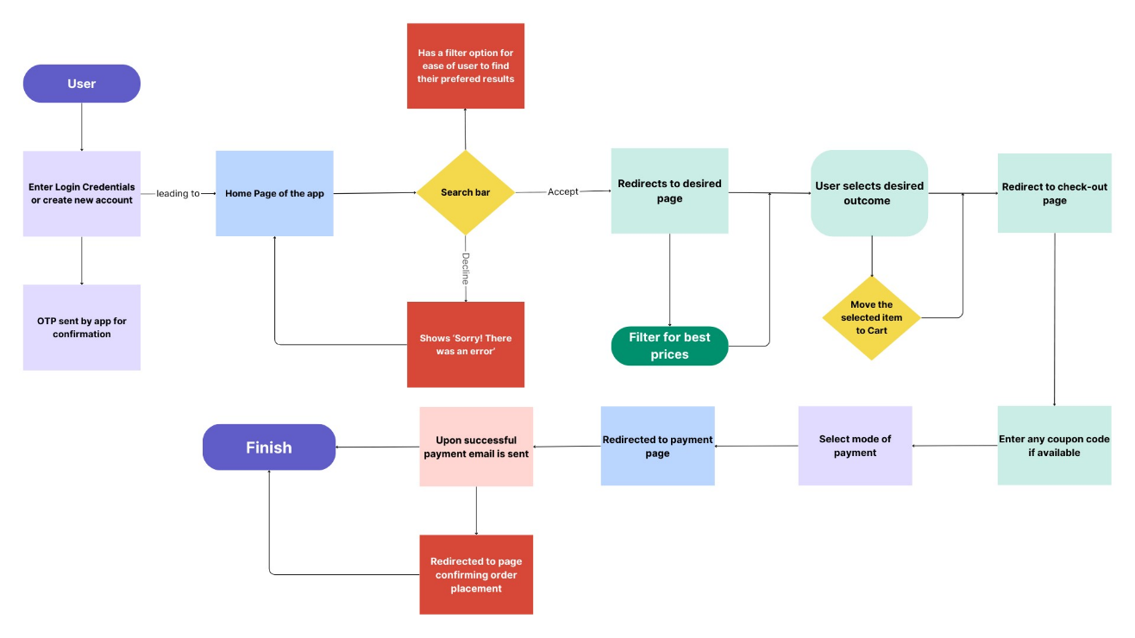

DFD for ***Wanderlust***

**User Stories**

Use the below template to list all the user stories for the product.

|  |  |  |  |  |  |
| --- | --- | --- | --- | --- | --- |
| **User Type** | **Functional**  **Requirement (Epic)** | **User Story Number** | **User Story / Task** | **Acceptance criteria** | **Priority** |
| Customer (Mobile user) | Registration | USN-1 | As a user, I can register for the application by entering my email, password, and confirming my password. | I can access my account / dashboard | High |
|  |  | USN-2 | As a user, I will receive confirmation OTP once I have registered for the application | I can receive confirmation OTP & enter in the desired spot | High |
|  |  | USN-3 | As a user, I can log into the application by entering email & password |  | High |
|  | Home | USN-1 | As a user, I can select the field I’m interested in |  | High |
|  |  | USN-2 | As a user, I can select the offer provided by the service provider |  | Medium |
|  | Search Bar | USN-1 | As a user, I can search for my desired product or package | I can click on enter to be redirected to the desired page | High |
|  |  | USN-2 | As a user, I can filter my search results to get the best results |  | High |
|  | Cart | USN-1 | As a user, I can go to cart to overview the package/ bookings I selected | I can click the icon of cart provided to direct myself to the cart contents | High |
|  | Check-out Page | USN-1 | As a user, I can choose the choice of my mode of payment and make the necessary payments through this page. |  | High |
|  |  |  |  |  |  |
|  |  |  |  |  |  |
|  |  |  |  |  |  |